**Journal of Applied Computer Science & Artificial Intelligence**

**Research Paper Vol.-2, Issue- 1, June 2022 ISSN: 2582-8673**

S-CART | WELCOME BUDDY

**SHUBHANJAN BARAI1*, RIYA DUTTA2, SANA ASGAR3, SAUNAK NANDI4, SONALI BHATTACHARYYA5, DR. PRANATI RAKSHIT6**

1,2,3,4,5,6 Department of Computer Science & Engineering, Kalyani, Nadia, West Bengal, India

**Available online at: http://jacsai.org**

Received: ………./2022, Revised: ………..2022, Accepted: ………2022, Published:.. /June/2022

*Abstract*— The Purpose of the project is to provide a student friendly Website. Students have mobile on which they play games, watch movies also do shopping. It's a hectic work to find products which are of good quality and long lasting. S-Cart provides multiple options to choose like bags, mugs, pencil box, bottles, reading materials, toys for learning etc. Student can log into the Website and can fulfill their wish by ordering great products in low price. After a lot of Research, we found many problems in some of the E-commerce website are very complex to use, but S-Cart has a great User Interface or rather Colorful Interface to engage more people. Even Parents can Order for their Kids, some gifts or other regular used products. Even parents can use the “Emergency Delivery” mode to get the products delivered early but for this early delivery additional charges are applied on the whole amount, but this will ultimately result in the happiness of their Kids. As the website will grow more features will be added further. In Simple words, the purpose of S-Cart is to add happiness in the life of an individual.

Keywords—E-commerce, User friendly website, Huge target audience, New Delivery mode, Great Quality Products

# **Introduction**

Business transaction of any form which is managed online is referred E-commerce. One of the best examples of E-commerce is online shopping, online shopping can be of anything like buying goods or selling of goods through internet. We can do online shopping from any device. Apart from online shopping we can also perform various other works such as internet banking, ticketing, payments and online auction. E-Commerce also known as electronic commerce is dealing of services or goods on cyberspace. It is your crowded city centre or brick and mortar shop which is interpreted into zeroes and ones on the information superhighway. Around 2.14 billion individuals worldwide tend to buy services and goods online. E commerce is a way for numerous people for buying and selling products in retail. E-Commerce gives an opportunity to small business and large companies or start-ups to sell their goods and connect with people around the globe. There are number of companies that uses E-Commerce to sell their products online but for numerous companies it is a distribution channel which is included in broader strategy like physical store and revenue system.

S-cart is an online shopping website that means an e Commerce website where people of all ages can buy stationary products such as scissors, project paper, pencil box etc. within a very affordable price range.it takes care of all security aspect and assist the user secure order and payment. Both logged in and guest user can use and shop from the website securely. Users can make a secure payment through PayPal or debit card or credit card or cash on delivery.

**The purpose of the contribution statement** is Nowadays retail stores are facing huge competition in the market. Good store designs are seeking more customer attention toward their stores and are increasing the store goodwill and cost also plays a major role in seeking customers' attention and selection of their store. Industry research has shown that there is much need to know about the customer's expectations, their preferences, choices, and the features expect from the store or shop. And we will find out the possible solutions for creating and developing the best store which will get more customers and produce more profits

# **Related Work**

In paper [1] Mark Anthony Camilleri discussed about the critical factor of online service delivery of an electronic commerce (e-commerce) websites which includes website attractiveness and website functionality, website security and

consumer fulfillment during an unprecedented Coronavirus (COVID-19) pandemic. The survey instrument relied on valid and reliable measures relating with electronic service quality (e-SERVQUAL), to better understand the satisfaction of participants with shopping websites as well as their loyal behaviors and word-of mouth activities. So, this discuss helped us to understand that online merchants should consistently deliver a personalized service in every stages of an online purchase which includes after the delivery of the ordered products.

In paper [2] Abeer S. Alkhalfan, Zainab W. Altheeb, Noor A. Proposed that the UML is the standard language for specifying, constructing, documenting and visualizing every

software system that artifacts as well as for other non-systems software and businesses modeling. The UML denotes a bunch of best engineering practices that have demonstrated success in complex and large systems modeling. The application architects and programmers, using UML can make a project blueprint, which makes the actual process of software development quite easier. Hence, we have kept this discuss in our consideration and designed our project.

In paper [3] Dr. Shahid Amin Bhat and prof. Kehsav kansana discussed about payment gateway which is an e-commerce application service provider service that authorizes credit card payments for e commerce businesses, online bricks and clicks, online retailers and traditional brick and mortar. The blood or life of online business is the payment routes that comprises credit card, debit card, online banking payments, electronic funds transfer. Nowadays The world has transformed from cash to digital money and thus there is a need of payment gateway for sustainable future of e-commerce. This directed us to create an easy and fast gateway and also keep an option for cash on delivery.

In paper [4] Farid Aulia Tanjunga*, Wawan Dhewantob explained that website products development study is focused to improve web structure and ease of use. Questionnaire result indicating that those factors which has significant impact in influencing customers doing online shopping, but expectation is still lagging beyond an appropriate result. It could be opportunity for e-commerce websites to build competitive advantages by advancing web structures and increasing the ease of use. Thus, making us realize the importance of user-friendly websites. And also guided us how to gain major customer attractions.

In paper [5] Gabriella Beronius Sarah Andrén discussed that

Graphical design is described as a discipline of visual communication that embraces several areas (Gomez-Palacio & Vit, 2009). It keeps us engage everywhere we go and includes everything from the magazine that we read to the signs we can see on the streets. By acting on our emotions which help us to form our attitudes towards things, graphic design could become a determinant of what differentiates one organization from another (Newark, 2007). If graphics design is the language, then visual communication is what we chose to speak to a targeted group through things such as images, colours, types or symbols. The process of the visual communication is that affecting the receiver by first evolving a feeling and then design a thought which will contribute to a final act. This gives us an idea of effective graphical design.

# **Methodology**

For the methodology part, the website system is parted in three vital roles, 1) Front-end for the user interface, 2) Backend for storing and organizing data, 3) Database Management System.

**Front-end**: - Front-end technologies are related to the User Interface and more visible. Changes in your front-end will directly change the user experience in powerful and meaningful ways. At the first when the user enters into the website using the link, user get a web page called home page which is always located in the root directory of any website. The home page includes a navigation bar that provides links to different sections within the website and a search bar that allows users to search for what they are looking for.

**Back-end**: -The back end processes the data from front-end to database and when required it also processes the data from database to front-end. Basically, NodeJS is highly scalable and powerful language for back end.

**Database**: - Database is used to store the important data for the user when he/she will store the items in the cart, whenever they login checking their credentials, displaying the cart items, displaying the products in the UI section etc. MongoDB Cloud works fine and is highly scalable in terms of storing data securely.

To represent the workflow of the E-commerce website, the flow diagram of s-cart as follows in the figure 1.

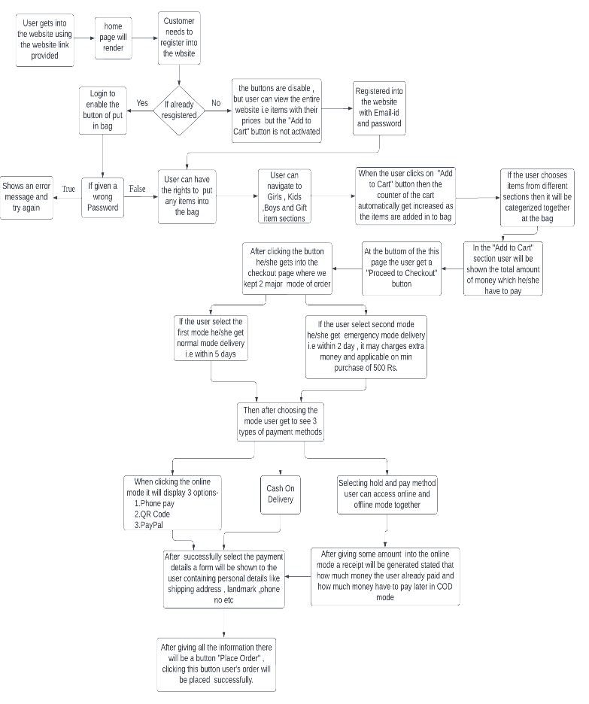**Flow Diagram:** -

# **Results and Discussion**

The ‘S -CART | WELCOME BUDDY’ service aims to provide solutions to develop and transfer in an easy and efficient way in this generation of digital India and to help save human time and make things comfortable with the help of technology. It is a website specially designed for students, where they can purchase a variety of stationery items from the comfort of their homes or hostels or wherever they are present then. “WELCOME BUDDY” is an e-commerce website that is very student-friendly and helps students to overcome the shortage of stationery products such as scissors, project papers, designed in a user-friendly manner. It features a familiar and well-thought-out, attractive user interface, combined with strong searching functionality.

Figure 1: Flow Diagram of S-CART

Home Page Preview: -

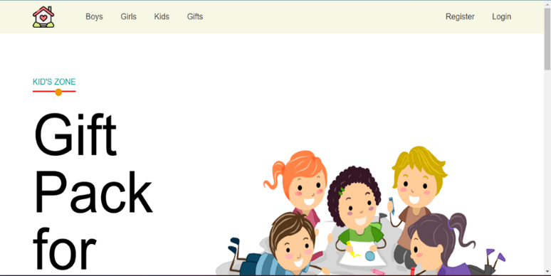

Figure 2: Home Page Interface

On the login and registration page, existing customers can log in to buy products and new users have to create an account for buying the product. The customer is assured that their personal information and data will not be shared and hence secured. The figure for the user login and registration page is given below in Figure 3 & Figure 4 respectively.

Login Page Preview: -

Figure 3: Login Page Interface

Registration Page Preview: -

Figure 4: Registration Page Interface

In the home page we also have different sections for everyone that are Boys’, Girls’, Kids’, and Gifts’ items where people can go and buy according to their wish. The sections preview of Boys’ is shown in Figure

Boys’ Section Preview: -

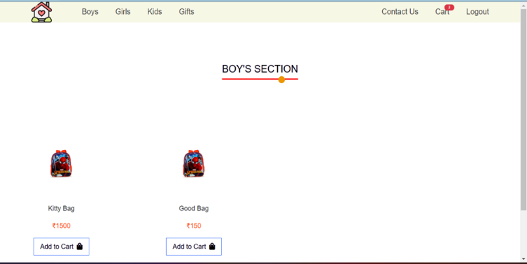

Figure 5: Boys’ Section

Accordingly, the Girls’, Kids’ and Gifts’ sections are also there.

At the Add to Cart Section when user Add some items , then it we reflect into the cart section and it will also show the amount of money the user have to pay. Figure 6 will show the whole process.

Figure 6: Cart Page Interference

At the final check out section, the user have to give the shipment details to proceed further. By providing the details the user can enter into the payment section. The figure 7 is for the Final Checkout and Add Shipping Information method is given below:

Figure 7: Checkout Page for user

This website consists of two modes of orders which are Normal Mode and Emergency Mode.

Figure 8: Payment Section

In normal mode, the product is delivered on the usual date which is within two to four days. The emergency mode is used when the product is required by the student urgently and the product is delivered in a very short period of time. As emergency mode gives extremely fast delivery additional charges will be applied depending upon the distance and time given for delivery. Figures 9 and 10 represent the normal and emergency mode.

Figure 9: Modal to understand Normal Delivery

Figure 10: Modal to understand Emergency Delivery

Another most important features are the three modes of payment methods which are Online payment, Cash on delivery, and Hold and Pay payment. As a result, this website proves to be the best friend in the lives of college or school students making their work easier and swallowing a lot of their time.

# **Conclusion and Future Scope**

This project is created to satisfy the needs of a student and help them whenever there is a need for some stationary products. This website shall prove to be a simple and reliable website in satisfying all the requirements of the buyers. The main motive of this website is to provide students with all types of stationary products necessary for their studies or projects. This website provides a variety of products that will benefit the customers visiting this website. It makes the entire process online where users can search for the by-products of their choice and needs. It also has a facility where users can log in and see the status of their order as well as request items or give their feedback. It provides the facility of admin’s login where admins can add or update various items, review users' activity and also give holiday discounts or holiday sales. In general, every business always strives to create the best possible things that customers will prefer and find valuable because consumers continue to like their quality of products, services, cost of products, and discounts to continuously be better, faster, and affordable. In this generation of new technology, businesses need to consider the new needs and choices of the customers because it is important for the growth, sale, and survival of their business. E-commerce is continuously advancing and evolving and is becoming more and more important and demanding to businesses and to the customers because of the advancement of technology. From the growth and development of the Internet and e-commerce, the possibilities have become endless for both businesses and customers thereby creating more opportunities for profit and advancements for businesses, while creating more product choices for customers.

The scope of E-commerce is expanding day by day and will become more advanced in the near future due to the huge number of internet users from every corner of the world. People are investing more time in looking for products and deals/sales in their favorite eCommerce platform. Mostly there are mobile users, in future S-Cart will be available in Mobile Version also. Android Development of the Website will be the Future but for the time being it will be a Web-app.

Many users are confused whenever they visit any website, if there is any assistant that will help them in directing or guiding about the different components of the website. It’s basically a contact assistant where auto generated messages will be coded and answer will be set accordingly. Advertisement plays an important role in promotion of the website and its products. It will also be done to attract customers from different part of the country. Discounts and offers will also be endorsed to attract customers.

##### **Acknowledgment**

First of all, we would like to thank our supervisor of the project Mrs. Sonali Bhattacharyya for her wonderful support, assistance and guidance while creating this project. Without her it would not be possible to complete this project. We would also like to show our gratitude to Mrs. Pranati Rakshit for making it possible for us to perform our project and for all her support. And finally, we would like to thank all the members of our who helped to create the

Project.

##### **References**

1. Mark Anthony Camilleri, "E-commerce websites, consumer order fulfillment and after-sales service satisfaction: The customer is always right, even after the shopping cart check-out" , University of Malta, Malta and University of Edinburgh, Scotland.(2021).
2. Abeer S. Alkhalfan, Zainab W. Altheeb, Noor A. Alshamsi, Heba W. Alothman,  "Designing and Developing of E-Commerce Website for Unused New Goods 2020" , International Journal of Scientific Research in Science and Technology IJSRST | Volume 7 ,Issue 2 , Print ISSN: 2395-6011 .
3. Dr. Shahid Amin Prof. Keshav Kansana ,Jenifur Majid,"A Review Paper on E-Commerce " .
4. Farid Aulia Tanjunga*, Wawan Dhewantob,"Formulation of E-Commerce Website Development Plan Using Multidimensional Approach for Web Evaluation",1877-0428 © 2013 The Authors. Published by Elsevier Ltd,ocedia - Social and Behavioral Sciences 115 ( 2014 ) 361 – 372.
5. Gabriella Beronius, Sarah Andrén, " E-Commerce Web design – The importance of a first impression" , Fall 2016: KANI12.
6. Lulu Cai, Xiangzhen He*, Yugang Dai, Kejian Zhu,"Research on B2B2C E-commerce Website Design Based on User Experience" First International Conference on Advanced Algorithms and Control Engineering IOP Publishing IOP Conf. Series: Journal of Physics: Conf. Series 1087 (2018) 062043 doi :10.1088/1742-6596/1087/6/062043.
7. Abdul Gaffar Khan,"Electronic Commerce: A Study on Benefits and Challenges in an Emerging Economy", Mawlana Bhashani Science and Technology University, Bangladesh, Volume 16 Issue 1 Version 1.0 Year 2016.
8. VIPIN JAIN1, BINDOO MALVIYA2, SATYENDRA ARYA,"An Overview of Electronic Commerce (e-Commerce)" , Journal of Contemporary Issues in Business and Government Vol. 27, No. 3, 2021.
9. E S Soegoto, A Christiani and D Oktafiani,"Development of E-Commerce Technology in World of Online Business", Volume 407 ,9 may 2018.
10. Anand Upadhyay,  Ambrish Pathak,  Nirbhay Singh,"Evolution of online shopping: E-commerce",International Journal of Commerce and Management Research,Volume 3; Issue 6; June 2017; Page No. 94-98.

**Authors Profile**

Author SHUBHANJAN BARAI is pursuing Bachelor of technology (B.Tech) in Computer Science and Engineering from JIS College Of Engineering , Kalyani , Nadia.

Author RIYA DUTTA is pursuing Bachelor of technology

(B.Tech) in Computer Science and Engineering from JIS College Of Engineering , Kalyani , Nadia.

Author SANA ASGAR is pursuing Bachelor of technology

(B.Tech) in Computer Science and Engineering from JIS College Of Engineering , Kalyani , Nadia.

Author SAUNAK NANDI is pursuing Bachelor of technology (B.Tech) in Computer Science and Engineering from JIS College Of Engineering , Kalyani , Nadia.

Author SONALI BHATTACHARYYA is an Assistant Professor of Dept of CSE at JISCE, of a renowned engineering college. Her research domains are Soft Computing, Machine Learning, Bio Informatics etc.

Author Dr. PRANATI RAKSHIT presently working as an Assistant Professor at JIS College of Engineering, Kalyani, Nadia, West Bengal, India. She has completed her Ph.D. degree from Jadavpur University, Kolkata, West Bengal, in the field of Pattern Recognition, Machine Learning and Medical image analysis She has worked in the field of Pattern Recognition, Machine Learning and Medical image analysis, Data Mining, image Processing, IOT etc. She has 45 numbers of research publications in international journals conferences including SCI and Scopus indexing.